

Methods of calculation of Böhm’s correlation
Bohumil Böhm
Vladimír Böhm

At the territory of Mexico, Guatemala, Belize, North-West Salvador and West Honduras major Indian cultures had been forming over millennia, of which the Mayan culture accomplished the highest development in that region. The complex economical and social process was based on agriculture, which succeeded in producing sufficient nutrition, allowing ultimately the population to grow to a degree when a smaller portion of it could increasingly undertake non-agricultural activities. The cyclically repeating field works gradually reached a level of sophistication when the full available labour force needed no more to be employed. In the farming settlements of the different communities specific individuals specialised in various artisan jobs, trade, building professions, as well as art and spiritual life. The villages gradually became venues of social contact, where not only agricultural and artisan production and trade concentrated but also accumulation and exchange of knowledge, experience and views took place. Moreover, local religious cults formed there together with their respective ceremonies. Bigger population permitted to organise and undertake ever more demanding and bigger construction projects, such as the early rather simple earthen cathedral tumuli topped with wooden sanctuaries replaced later with stone pyramids, cathedrals and whole magnificent cathedral cities. The early forming of the Mayan culture dating roughly to the 15th century B.C. was probably influenced by the noteworthy Olmec culture from the Vera Cruz and Tabasco regions. While the progressive development from simple villages to magnificent cathedral cities took place in the Mayan culture analogously to that in other Indian cultures in Mexico, it differed notably in spiritual culture in which the level achieved by the Mayas was so high that their intellectual accomplishments outpaced their simple technological knowledge and potential to a degree rendering them inapplicable in practice. Although the original impulse is probably attributable to the Olmec culture, it was the Mayas who developed a system of hieroglyphic writing and a highly complex calendar. In particular, the findings obtained in their astronomical observations, their calculations relating to the course of the tropical year (the equinoxes) as well as those of the lengths of synodic orbits of all visible planets and their mutual conjunctions, of the maximum elongations of Mercury, or their calculations of solar and lunar eclipses are truly amazing.
Despite its intellectual accomplishments, the technological level of the Mayan society stayed throughout its historical developments essentially at the early Stone Age level. Moreover, the culture proved unable to resist their militarily better organised and more aggressive neighbours from Central Mexico. Since late 9th century and in the course of the 10th century, the Mayan culture crumbled under their onslaughts and yielded to foreign rule of their culturally less advanced conquerors. The coming of new ethnics (the Toltecs, Itzas, Tutul Xiu) resulted in a general decline of the Mayan society, apparent in all areas of culture. Over a very short time, dated hieroglyphic texts ceased to be made, which, in the classical period, used to cover the free surfaces of steles and monumental buildings. Likewise, the system of complex a extremely accurate calendar was forgotten. For dating, only the 260-days cycle (tzolkin) and the rather approximate dating using the 7200-day catuns became to be used. In the Codex of Madrid, which probably originated during the Mayan rule at Yucatan (roughly 1200-1450), we found proof of use of a leap-year system in combination with the 260-day tzolkin. It was a new system of dating, which appeared as late as during the 13th to 15th centuries. Due to its incompatibility with the system of the Mayan calendar from the classical period, the Mayas did not use leap years of 366 days. Rather the system was one involving a mutually compatible parallel run of a number of calendar cycles, which formed an accurate, and, for the Mayas, holly harmonic course of the Time. Any insertion of even a single day would result in its complete disintegration. The system involved the following calendar cycles:

the 260-day tzolkin meeting after l8,980 days
the 365-day haab (the calendar circle) meeting after
170,820 days
the 9-day cycle after 6,832,800 days,

all cycles met
the catun circle of 93,600 days split into
13 catuns of 7,200 days each. Each catun
comprised twenty 360-day tuns

In the Mayan calendar, every day had a number of names, depending with which day of the current cycle the day coincided. Moreover, the number of days elapsing until the date in question since the first day of the Mayan chronology was given – the so-called long count. This is why the Mayan dates range in extreme values of over one million days. In the analyses of Mayan dates presented below, all date values will be given strictly only in the long-count format, as presented on the pages of the Codex of Dresden, one of the rare surviving Mayan manuscripts.
Correct transformation of Mayan dates into the Christian (Julian) calendar rates among essential issues in Mayological studies. The so-called correlation between the Mayan and the Christian dating systems is important not only for the dating of the historical development of the Mayan culture, but also for that of the neighbouring cultures which were in contact with the Mayas and developed together with or preceded them. When calculating the correct correlation between the Mayan and the Christian systems, the conclusions so obtained must be confronted with historical events. There must be no discrepancy between the findings obtained from astronomical calculations and the actual dated events occurring historically. Out of over 40 correlations hitherto known, none meets this major requirement. While the so-called Böhm’s correlation proceeds from Mayan dates relating apparently to astronomical occurrences referred to in the Codex of Dresden as well as some inscriptions on monuments found in the cathedral cities, it also respects major historical aspects.
The Codex of Dresden is split into pages numbered according to older E.W. Förstemann version (denoted with F) and alternately the younger version developed by the Russian researcher Ju.V. Knorozov (denoted with D). Mayan dates spreading one or more pages form integral systems. As far as possible, their original topological position is maintained in their transcription, so that to avoid as little distortion in comparison to the original document as possible. Rather than given in the Codex directly with the number of days elapsed since the beginning of the Mayan chronology, i.e. the long count, some dates given in parentheses are identified only with the date from the 260-day tzolkin. From the relationship with the other dates given mathematically in the Codex, the actual number of elapsed days can be calculated.
The calculation of the correlation itself involves the establishment of the correlation factor designed to be added to the days with Mayan dates (the long count) given in the decimal format. Thereby, the Mayan days are transformed into the so-called Julian days, these to be in turn converted into the days, months, and years of the Christian (Julian) calendar. For the calculation itself, dates were used which we could assume, based on their mutual relationships, to relate to some remarkable astronomical occurrences noted by Mayan astronomers. To these dates, we allocated the corresponding astronomical phenomena as dated in the Julian dating system which occurred repeatedly a number of times between the years 100 and 1000 A.D., with a small shift in time either backwards or forwards, if required for the calculation. The differences in the number of days between each studied Mayan date of the given astronomical phenomenon and the actual Julian date of the same phenomenon resulted in a number of viable correlations for each Mayan date, of which only one however could be the correct one. All calculations are related to the rough centre of the Mayan region, i.e. 17 deg. of northern latitude and 90 deg. of western longitude. The exact time of the astronomical phenomenon is given for these geographical co-ordinates and it is late by 360 minutes against the global time.
The sets of Mayan dates from the Codex of Dresden were analysed using a combination of three work methods, namely:

1) using the chart of time cycles which define in the Codex which astronomical phenomenon
is most likely the one applied
2) analysis of the contents of the respective intervals of time elapsing between the dates
3) mathematical statistical analysis plus the non-integer residue method

Method A – Astronomical phenomena charts method

These charts of numerical values added to the initial dates apparently define the observability times of Venus and of the solar or lunar eclipse. These include the dates:

Page D24 (F 24) 9.9.9.16.0 1 Ahau 18 Kayab 1,364,360 days

It was as early as by E.W. Förstemann and J.E. Teeple (1926) discovered that the date relates to the orbit of Venus. To this date, multiples by the factor of five of the interval of 2,920 days are added. The following concurrence in included in the date:

5 times the length of the synodic orbit of Venus rounded to 584 days
13 times the length of the sideric orbit of Venus (224.700 9 days)
8 times the length of the tropical year (365.242 199 days)

2,290 days is the base period in which the concurrence of the synodic and sideric orbits of Venus occurs and the planet rises or sets in one and the same point on the sky. Moreover, the synodic orbit of 584 days is further split in the Codex charts into:

236 days – Venus is found in the eastern sky as the Morning Star
90 days – Venus is near its upper conjunction with the Sun as not
observable
250 days – Venus is found in the western sky as the Evening Star
8 days – Venus is near its lower conjunction with the Sun as not
observable

It follows from the above split-up of the length of the synodic orbit of Venus, as made by the Mayan astronomers that the Mayan date 9.9.9.16.0 1 Ahau 18 Kayab relates to the moment when the planet first shows in the
morning sky as the morning star after passing its lower conjunction with the Sun. For the time interval in consideration, 563 passages of Venus through its lower conjunction with the Sun were calculated. To that, 563 possible correlations correspond.

Page D 31 (F 52) 9.16.4.10. 8 12 Lamat 1,412,848 days

This date has been earlier identified by researchers as the initial date of a series of solar or lunar eclipses following after the date (M. Meinshausen, C. E. Guthe, H. Spinden). To the date, the cyclic saros of 11,960 days containing 405 synodic orbits and 439.5 draconic orbits of the Moon is added. Furthermore, the said period is subdivided in the charts into shorter intervals of 148, 177 and 178 days, to which additional eclipses relate, both solar and lunar. The charts can be used for both phenomena. From 13th September 117 until 31st August 1011, the total of 281 solar eclipses visible from the region populated by the Mayas occurred, some of which located at the observability limit. For that phenomenon, 281 correlations were calculated. There were 1,383 lunar eclipses between 21st October 115 and 26th September 1010. These are always observable virtually from all over the globe. Hence, to avoid error, all these theoretically possible and observable eclipses were taken account in the correlations calculation, yielding 1,383 correlations.

Method B – analyses of respective time intervals between dates

This method is based on establishing whether the following intervals are contained between the Mayan dates:

1) multiples of the lengths of the synodic orbits of the different visible planets
2) multiples of concurrence of the length of the synodic and sideric orbits of the different
planets
3) multiples of concurrence of the length of the synodic and sideric orbits of two or more
planets
4) multiples of the basic cycles of conjunctions of planets
5) multiples of the length of the tropical year

Based on the above analyses it is possible to presume which astronomical phenomenon can relate for selected dates. The following Mayan dates from the Codex of Dresden were chosen which form on one ore several successive pages a topological integral group:

Page D 24 (F 24) 9.9.16.0. 0 4 Ahau 8 Cumku 1,366,560 days
- 6.2.0 - 2,200 days
9.9.9.16. 0 1 Ahau 18 Kayab 1,364,360 days

The time interval of 2,200 days indicated between the dates in the Mayan text contains:

19 times the length of the synodic orbit of Mercury (115.877 484 days)
25 times the length of the sideric orbit of Mercury (87.968 581 days)
6 times the length of the tropical year (365.242 199 days)

2,200 days is the typical period of concurrence of the synodic and sideric time of orbit of Mercury with the tropical year, when the planet rises or sets in approximately one and the same point in the sky after six years time.

Both dates can be assumed to relate to observations of Mercury, when it was
located near its maximum western or eastern elongation from the Sun.
It is only in these positions when the planet is best observable in the morning shortly before the sunrise or in the evening shortly after sunset. For both these positions of the planet, 5,674 possible correlations were found over the studied time interval.

Page D 37 (F 58) 9.18.2.2.0 4 Ahau 1,426,360 days
9.12.11.11.0 4 Ahau 1,386,580 days

These two dates are separated with the time interval of 39,780 days containing the following intervals:

68 times the length of the synodic orbit of Venus rounded to 585 days
177 times the length of the sideric orbit of Venus (224.700 64 days)
51 times the length of the synodic orbit of Mars rounded to 780 days
58 times the length of the sideric orbit of Mars (686.980 38 days)
17 times the basic average cycle of conjunctions of Venus with Mars
(2.340 days)
153 times the holy tzolkin cycle of 260 days

The actual length of the synodic orbit of Venus ranges between 577 and 592 days. Its mean length is 583.921394 days. Moreover, by the superimposition of the movements of the Earth and Venus a seemingly irregular loop-like movement of the planet appears to exist in the sky involving 542 and 42 days of forward and backward movement respectively. Also Mars moves analogously. The length of its synodic orbit varied from 764 to 810 days. The forward and backward movements last 706 and 74 days respectively. The mean length of the synodic orbit of Mars is 779.936 2 days. The basic theoretical cycle of repetition of conjunctions of Venus with Mars is the 2,340-day period. The cycle varies roughly from 2,315 to 2,360 days. From the relationship of the time data between the above two Mayan dates, the studied dates can be inferred to likely relate to the conjunctions of Venus with Mars. Apparently, the Mayas realised from their long-term observations the complexity of the movements of these planets. This is why they worked with the mean values, which allowed the calculation of the conjunctions of the two planets for over a long period of time with very small error. Moreover, the interval elapsed between the two dates contains multiples of the 260-day holy tzolkin. The same page of the Codex includes another entry, namely:

      - 4 Ahau 1,426,360 days
- 12.11 - 251 days
(9.18.1.7.9) 13 Muluc 1,426,109 days

If the conjunction with Mars occurs at the moment when Venus is located as the Evening Star near its eastern elongation from the Sun, the next conjunction will take place around the western elongation of Venus in the morning sky, with the planet shining as the Morning Star. With that position, the time interval between the two conjunctions is very short, ranging between 206 to 295 days, the mean interval being 251 days, as noted in the Mayan texts. Apparently, the first date denotes the conjunction of Venus with Mars in the morning sky, the other standing for the same phenomenon occurring s in the evening star after sunset. The dates from page D 37 (F 58) relating to the conjunction of Venus with Mars were not used in the first phase of the correlation calculation and served for the final check of the calculation process.

Page D 42 (F 63) 10.13.13.3.2 1,538,342 days - 7.2.14.19 - 51,419 days
(10.6.10.6.3) 13 Akbal 1,486,923 days

In the interval of 51,419 days between the two dates, 136 times the length of the synodic orbit of Saturn (378.091 904 days) is contained. Probably, the observation was one covering a long term, or it involved the calculation of the length of the synodic orbit of the planet. This can be determined proceeding from the heliactic settings, when Saturn is the last time visible in the evening sky shortly after sunset, since its gets into conjunction with the Sun. After passing through the conjunction, when the planet was no more visible in the sky for dozens of days, it rises again in the morning sky shortly before the sunrise – the so-called heliactic rising. Both dates can be assumed to relate to the heliactic settings or risings of the planet. The dates from page D 42 (F 63) were not used for the correlation calculation, serving for the final check of the calculation procedure.

Moreover, the method of analysis of the respective time intervals between the dates in the Codex of Dresden was applied for selected dates appearing in the inscriptions found at the cathedral cities. An intriguing fact was discovered, i.e. that among different dates groups appearing in the inscriptions 4 to 8 times over, multiples of the tropical year are contained with high accuracy. Alternately, after deducting the multiples, the residual number of days equals the length of the time interval in days between the nodal points of the tropical year, i.e. the solstices and equinoxes. At the same time, the date groups relate to specific dates in the Codex. These are for example:

Codex of Dresden,
page D 41 (F 62) 8.16.15.16.1 1,272,921 days

Piedras Negras,
steles 3, 7, 8: the date
appears 5 times over 9.11.12.7.2 2 Ik 10 Pax 1,379,662 days

Copan, altars R, Q, T, U, V,
stele 8, cathedral 11 (twice):
the date appears 8 times 9.16.12.5.17 6 Caban 10 Mol 1,415,637 days

An example of the mutual relationship between the dates of this group, which relate to the nodal points of the tropical year can be presented for the last two dates given above.Between 1,415,637 days and 1,379,662 days, there is the interval of 35,975 days. This interval contains 98 tropical years plus 181.3 days as the residue, which, in turn, is the interval between the summer and winter solstices. For the correlation calculation, the date of 1,415,637 days from

Copan was used, for which four possibilities were assumed, namely two solstices and two equinoxes. In the time interval studied, 3,600 correlations existed.

Method C – mathematical statistics analysis plus the non-integer residues method

To improve the speed and flexibility of our efforts, another method was applied, which we called the non-integer residues method. The principle of the method lies in dividing the different Mayan dates with a respective special constant number, such as the length of the tropical year, i.e. 365.242 199 days. After deducting the integer portions we arrived at a set of decimal numbers ranging from 0.000 1 to 0.999 9, depending on the setting. The set was arranged in the ascending order and studied whether or not it contains groups of identical or close values with frequencies beyond those of a random distribution. Such a group would then stand for dates separated with the difference of n times 365.242 199, i.e. the length of the tropical year.
Our non-integer residues method has been mainly applied in statistical operations when the mathematical analysis findings of a sample of specific Mayan days are compared with a sample of the same size of random dates in thousands of model calculations. A sample of Mayan dates is considered to be a group of dates arranged in a special topological arrangement, within specific limits or featuring other common characteristics indicating the dates to belong to an integral set, which could stand for an account of a periodic phenomenon. This means that the studied Mayan dates sample is found in a single or two adjoining pages of the Codex of Dresden to which different time intervals are assigned from the below charts. Moreover, the common features for different dates include the same accompanying hieroglyphs.
Our findings are also supported by the degree of verification of observations published by the present authors, using a statistical method designed for the purpose. The principle of the method can be demonstrated on a simple example.
In the Codex of Dresden, pages D 41- 42 (F 62-63) present the following dates:

8.16.15.16.1 1,272,921 days
- 1.4.16 - 456 days
(8.16.14.11.5) 3 Chicchan 1,272,465 days

8.16.14.15.4 1,272,544 days
- 6. 1 - 121 days
(8.16.14.9.3) 13 Akbal 1,272,423 days

      - 1,234,220 days
- 11.15 - 235 days
(8.11.7.13.5) 3 Chicchan 1,233,985 days

8.16.3.13.0 1,268,540 days
- 0. 17 - 17 days
(8.16.3.12.3) 13 Akbal 1,268,523 days

10.8.3.16.4 l,499,004 days

10.13.13.3.2 1,538,342 days
- 7.2.14.19 - 51,419 days
(10.6.10.6.3) 13 Akbal 1,486,923 days

(8). 19. 0. 4. 4 1,288,884 days

A tentative analysis of the above twelve dates has revealed that six of them contain with high accuracy the integer multiple of the mean synodic orbit of the planet of Mercury (115.877 484 days). These six dates were assumed to relate to observed or calculated position of Mercury. Probably, the dates can relate to the days of visibility of the planet in its maximum elongation with the Sun, when it is at the greatest angular distance from the Sun and is also observable the best. As random effects cannot be ruled out, a statistical calculation is applied which will reveal the random percentage of such coincidence. Dividing all the dates converted in the decimal numerical system with the length of the synodic orbit of Mercury and after deducting the integer part, the following ratios and non-integer residues are obtained:

1,272,921 : 115.877 484 = 10,985.059 0.059
1,272,465 : 115.877 484 = 10,981.124 0.124
1,272,544 : 115.877 484 = 10,981.805 0.805
1,272,423 : 115.877 484 = 10,980.761 0.761
1,234,220 : 115.877 484 = 10,651.077 0.077
1,233,985 : 115.877 484 = 10,649.049 0.049 The non-integer residues
1,268,540 : 115.877 484 = 10,947.252 0.252
1,268,523 : 115.877 484 = 10,247.105 0.105
1,499,004 : 115.877 484 = 12,936.111 0.111
1,538,342 : 115.877 484 = 13,275.590 0.590
1,486,923 : 115.877 484 = 12,831.854 0.854
1,288,884 : 115.877 484 = 11,122.8l6 0.8l6

The non-integer residues of the six dates of the above group in consideration are as follows:
0.049
0.059
0.077
0.105
0.111
0.124
The difference between the highest and lowest value is 0.075. Relatively to the synodic orbit of the planet this represents the mean deviation of +/- 4.345 days. This results from the real-life observation conditions, such as the different length of the synodic orbit of Mercury, which ranges from 104 to 132 days or the weather conditions. We compiled a computing programme, which analysed in a closed loop a group of 12 dates of roughly the same magnitude as the above Mayan dates from the Codex of Dresden. The random dates (generated in Turbo Basic using the RANDOMIZE and RND[x]) are divided in the step-wise fashion by 115.877 484. The non-integer residues so obtained were sorted by magnitude using a SORT function. Next, the differences between the first and the sixth, the second and the seventh, the third and the eighth, the fourth and the tenth etc. model residues in this set of twelve non-integer residues were established in a series of incremental steps (of one). If the same or smaller difference occurred as in the actual group of dates from the Codex of Dresden, i.e. 0.075, the programme incremented the current counter value by unity. It should be noted at this point that the studied random numbers series must be expanded to 17 numbers by the first five values of the series increased by unity. This follows from the fact that for example two non-integer residues 0.02 and 0.98 would not be taken into account without the series extension, although clearly meeting the precondition that the corresponding two model Mayan dates having these two non-integer residues contain in between them an all but integer multiple of 115.877 484. The closed loop carried out 10,000 identical repeated operations and the counter counted the total number of identical or more favourable events as found for the six dates from the group of twelve dates from the Codex of Dresden.
In the specific example described herein each series of 10,000 model situations (repeated a few times over) indicated around 120 positive phenomena, like for the dates indicated in the Codex of Dresden mentioned above. Therefore, the probability of chance coincidence, i.e. that the dates in the Codex are but randomly arranged, is 120 : 10,000, or 1:83. On the contrary, it means with certainty of 83:1 that the dates relate to the actual position of the planet of Mercury. By adding our ultimate correlation coefficient of 622,261 days to the individual of the six Mayan dates studied we found in the final stage of the calculation that Mercury was always situated in the vicinity of its maximum western elongation, the fact of which the Mayan astronomers apparently desired to indicate in the Codex.
Some Mayan dates from the Codex were not used for the correlation calculation although the time intervals between clearly indicate the astronomical phenomenon to which they relate. However, these dates served for the final check and verification of the calculated correlation. These include for example the dates from page D 37 (F 58) the time intervals between which clearly indicate conjunctions of Venus with Mars. using our non-integer residues method, five dates from pages D 4l-42 (F 62-63) were found to relate to the synodic orbit of the planet of Saturn. This original assumption of ours was confirmed at the final stage of the calculations. Therefore, dates relating to the following astronomical phenomena were used for the calculation of the correlation between the Mayan and Christian dating systems:

1) the heliactic rising of Venus after passing its lower conjunction with the Sun
2) solar or lunar eclipse (both alternatives taken into account)
- maximum elongations of mercury – the eastern and western one (both alternatives taken
into account)
4) the tropical year – solstices and equinoxes – four possibilities taken into account

For the above astronomical phenomena relating to the selected dates from the Codex and the cathedral cities, the total of 11,501 correlations were calculated ranging from 392,200 to 722,105, which stand for the numbers to be added to the long count of the Mayan dating system to convert these dates to Julian days and ultimately the dates of the Christian (Julian) calendar. Out of the total number of correlations, only three could be applied to the Mayan dates with assumed actual astronomical phenomena, such as the heliactic rising of Venus after its lower conjunction with the Sun, solar or lunar eclipses, and nodal points of the tropical year, but not with the maximum elongation of Mercury. Only a single correlation coefficient of 622,261 yielded favourable results for all selected data, taking also Mercury into consideration. The ultimate correlation coefficients as relating to the studied dates of the presumed astronomical phenomena are best shown in the below chart in which the Mayan dates are converted for the sake of simplicity into the decimal numerical system:

Final correlation coefficients: 438,906 530,584 600,070 622,261

1,364,360 days 27. I. 225 28. I. 476 26. IV. 666 27. I. 727
heliactic rising of Venus yes yes yes yes

1,412,848 days 29. X. 357 29. X. 608 26. I. 799 29. X. 859
solar and lunar eclipses solar lunar lunar solar

1,366,560 days 5. II. 231 5. II. 482 4. V. 672 4. II. 733
maximum elongation of no no no yes
Mercury

1,364,360 days 27. I. 225 28. I. 476 26. IV. 666 27. I. 727
maximum elongation of no no no yes
Mercury

1,415,637 days 18. VI. 365 18. VI. 616 15. IX. 806 18. VI. 867
solstices, equinoxes solstice solstice equinox solstice

It should be noted that the same correlation value of 438,906 was obtained by R.W. Willson in as early as 1924. However, this correlation coefficient fails to conform to the observed movements of Mercury or historical experience.
Using the correlation of 622,261 days, the different Mayan dates indicated in the chart relate to the following astronomical phenomena:

1,364,360 days = 27th January 727. Venus is 8 days past its lower conjunction
with the Sun. In the morning, seen for the first time as the
Morning Star (Figure 1).
Venus rose at 5.39 a.m.
The Sun rose at 6.34 a.m.

1,412,848 days = 29th October 859. Solar eclipse (Figure 2).
Beginning at 8.16 a.m.
Maximum at 9.42 a.m.
Ended at 11.23 a.m.
At its height, 75% of the Sun surface covered.

1,366,560 days = 4th February 733. Mercury in its western elongation at angular
distance from the Sun of 26.47 deg. (Fig. 3).
Mercury rose at 4.53 a.m.
The Sun rose at 6.32 a.m.
The maximum elongation of 26.73 deg. occurred on 31st
January 733. The difference between the calculated and
actual elongations is 0.26 deg.

1,364,360 days = 27th January 727. Mercury in its western elongation at angular
distance from the Sun of 25.50 deg. (Fig. 4).
Mercury rose at 4.55 a.m.
The Sun rose at 6.34 a.m.
The maximum elongation of 26.07 deg. occurred on 21st
January 727. The difference between the calculated and
actual elongations is 0.57 deg.

For both maximum western elongations of Mercury, the
Mayan astronomers made the mean error of –0.415 deg.,
which they were unable to measure.

1,415,637 days = 18th June 867. The summer solstice.

As verification of the accuracy of the calculated correlation the dates from page D 37 (F
58) were used, selected on the basis of an analysis of the contents of their respective time
intervals, relating quite clearly to the basic cycles characteristic for the conjunction of Venus
with Mars, as explained above. The Mayan dating system has been converted into the decimal mathematical system:

Final correlation coefficients: 438,906 530,584 600,070 622,261

1,426,360 days 27. X. 394 27. X. 645 24. I. 836 26. X. 896
no no no conjunction
- 251 days
1,426,109 days 18. II. 394 18. II. 645 18. V. 835 18. II. 896
no no no conjunction

1,386,580 days 28. XI. 285 28. XI. 536 25. II. 727 28. XI. 787
no no no conjunction

The conjunction of the two planets for three Mayan dates had the following course and their mutual positions are given in degrees of geocentric ecliptic coordinates:

1,426,360 days = 26th October 896. A conjunction of Venus with Mars (Figure
5).
Venus at 176.267 deg.
Mars at 175.374 deg.
The two planets are distanced by 0.893 deg.
The actual conjunction occurred two days earlier – on 24th
October 896.
Venus at 173.916 deg.
Mars at 174.117 deg.
The two planets are distanced by 0.201 deg.

1,426,109 days = 18th February 896. A conjunction of Venus with Mars (Figure
6).
Venus at 10.896 deg.
Mars at 9.966 deg.
The two planets are distanced by 0.93 deg.
The actual conjunction occurred two days earlier – on 16th
February 896.
Venus at 8.504 deg.
Mars at 8.507 deg.
The two planets are distanced by 0.003 deg.

1,386,580 days = 28th November 787.A conjunction of Venus with Mars (Figure
7)
Venus at 207.547 deg.
Mars at 204.765 deg.
The two planets are distanced by 2.782 deg.
The actual conjunction occurred one day earlier – on 27th
November 787.
Venus at 206.870 deg.
Mars at 204.115 deg.
The two planets are distanced by 2,755 deg.

For three calculated conjunctions of Venus with Mars, Mayan
Astronomers made the average error of +0.549 deg. The
difference against the actual position is so small that it was
well beyond detection with their measurement methods.

The two charts demonstrate that it is only the correlation coefficient of 622,261 which yields favourable results with all selected Mayan dates with the presumed astronomical phenomena. The accuracy of the correlation coefficient is further verified with other integral groups of dates from the Codex of Dresden which were tentatively found, using the mathematical statistical and the non-integer residues methods, to relate to specific astronomical phenomena, although these were not used for the correlation calculation. These include for example the heliactic risings and settings of Jupiter or Saturn, where the accurate definition of these events is difficult since they depend largely on the weather conditions in the observation point. Other dates relate to conjunctions of Jupiter with Saturn or double conjunctions of Mars with Jupiter and Saturn. When making the computing operations with the Mayan dates, the Mayan astronomers were given allowance in terms of accuracy of their observations of 1 – 6 days. The errors could result from a number of causes, such as:
1) their rather simple observation and measurement technologies
2) calculations made with integer mean times of astronomical phenomena, since the Mayas
knew no decimal numbers
3) their tendency to relate the holy 260 tzolkin cycle with cycles of recurrent phenomena in
the sky
4) some phenomena take a very slow course. For example, the declination of the Sun during
solstices changes very slowly, at the rate of about 1 degree over 20 days, a circumstance
apparently at the limit of the observation capabilities of the Maya. Also, in its maximum
elongation positions, Mercury often seems to remain standing in one and the same point
in the sky for a number of days and its angular distance from the Sun changes only
marginally.

Some astronomical phenomena, with the exception of solar and lunar eclipses, occur over a longer time interval and determining the accurate point in time for them is not easy. The interval of 1-6 days within which the phenomena were found to occur, corresponds to the technical means of measurement of the Mayan astronomers since the motion of the planets and the Sun in the sky is hardly perceptible over that time under certain conditions.
The above effects caused that some results according to the Mayan calculations fail the test of absolute accuracy from the viewpoint of current understanding supported by state-of-the-art measuring technologies, instrumentation and powerful computers. Nevertheless, the conclusions derived from astronomical observations and calculations as embodied in the dates and charts of the Codex of Dresden are amazing and inspire proper respect for the authors of that Book of Mayan astronomy. For example, the above dates given for the conjunctions of Venus with Mars (1,426,360 days, 1,426,109 days and 1,386,580 days) were calculated with a difference of mere one or two days against the actual occurrences. The angular distance of the two planets changed over the time for all three dates in the average by 0.549 deg. The difference against the actual configuration was so small that it could only be measured with the utmost difficulty. Moreover, it is quite clear that some dates for astronomical phenomena were calculated into both the past and the future and hence some minor errors were bound to occur, if the differences observed can be considered errors, given our perspective of technology of the 21st century. Using our correlation of 622,261 days we succeeded in establishing the meaning of all dates in the Codex of Dresden, which relate to conspicuous astronomical phenomena. The accompanying numerical charts serve for predictive calculations.
The accuracy of the correlation can be verified against specific historical events. Based on archaeological research and, later in the 16th century, written accounts, major ethnical religious and cultural changes are indicated to have taken plac during the 10th century throughout the Mayan society. As early as during the 9th century, gradual decay of the cathedral cities was taking place in the central Mayan region. Their collapse is explained by the penetration of Mexican marauders, probably of Toltec origin, from central Mexico. After 928, the Mexicans entered the Yucatan peninsula. In 16th century literature, they are called Itzas. Around 987, they conquered the major cathedral city of Chichen Itza, from which they spread their rule over Yucatan. With the occupation of Chichen Itza, the production of hieroglyphic inscriptions with dates ceased over a short time and the whole city was being reconstructed and expanded in the architectonic style of Toltecs, reminiscent of similar buildings from distant Tollan – the main centre of Toltec rule in central Mexico. According to our correlation, one of the last Mayan dates in the city was 31st May 993, i.e. it dates from the time of entrenchment of Toltec rule. Around 1007, other Mexican marauding groups from the nation Tutul Xiu occupied another major Yucatan cathedral city of Uxmal. While it escaped destruction or reconstruction, making of dated inscriptions ceased as well. The last Mayan date in the city according to our correlation is 19th September 1010.
The accuracy of correlation of 622,261 days by the means of which Mayan dates are converted to those of the Christian (Julian) calendar has been confirmed not only by the Mayan dates of astronomical phenomena in the Codex of Dresden but it is also the only correlation compatible with historical circumstances.

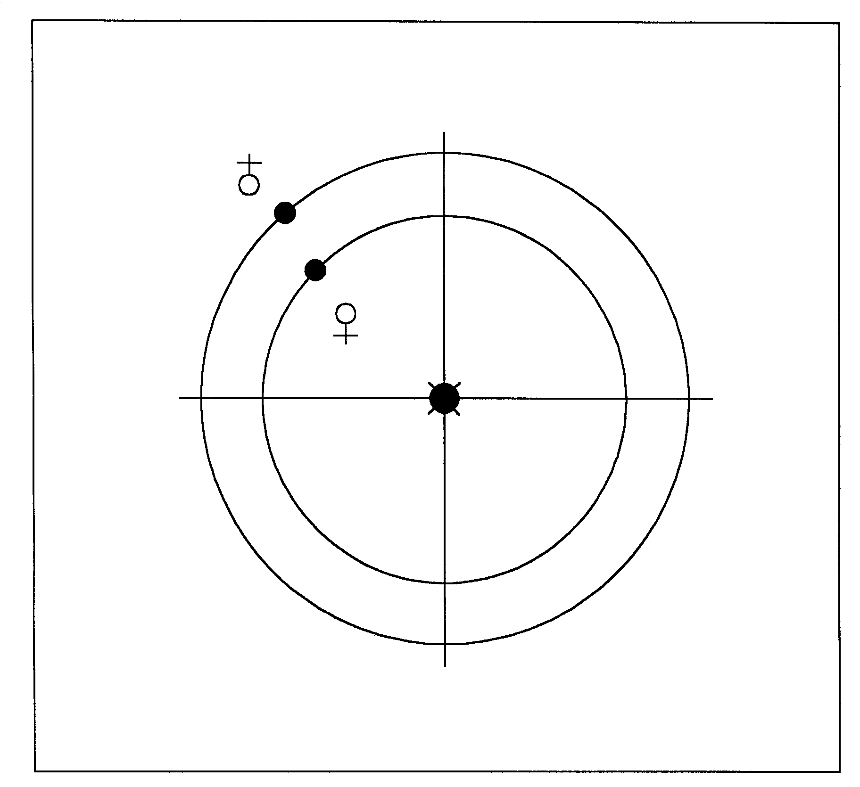
0⁰

180

180⁰
90⁰
270⁰

Figure 1
Venus 8 days past its lower conjunction with the Sun on 27th January 727.
In the morning, it is observed for the first time in the eastern sky as the
Morning Star. Date 9.9.9.16.0 1Ahau 18 Kayab. Codex of Dresden,
page D 24 (F 24).

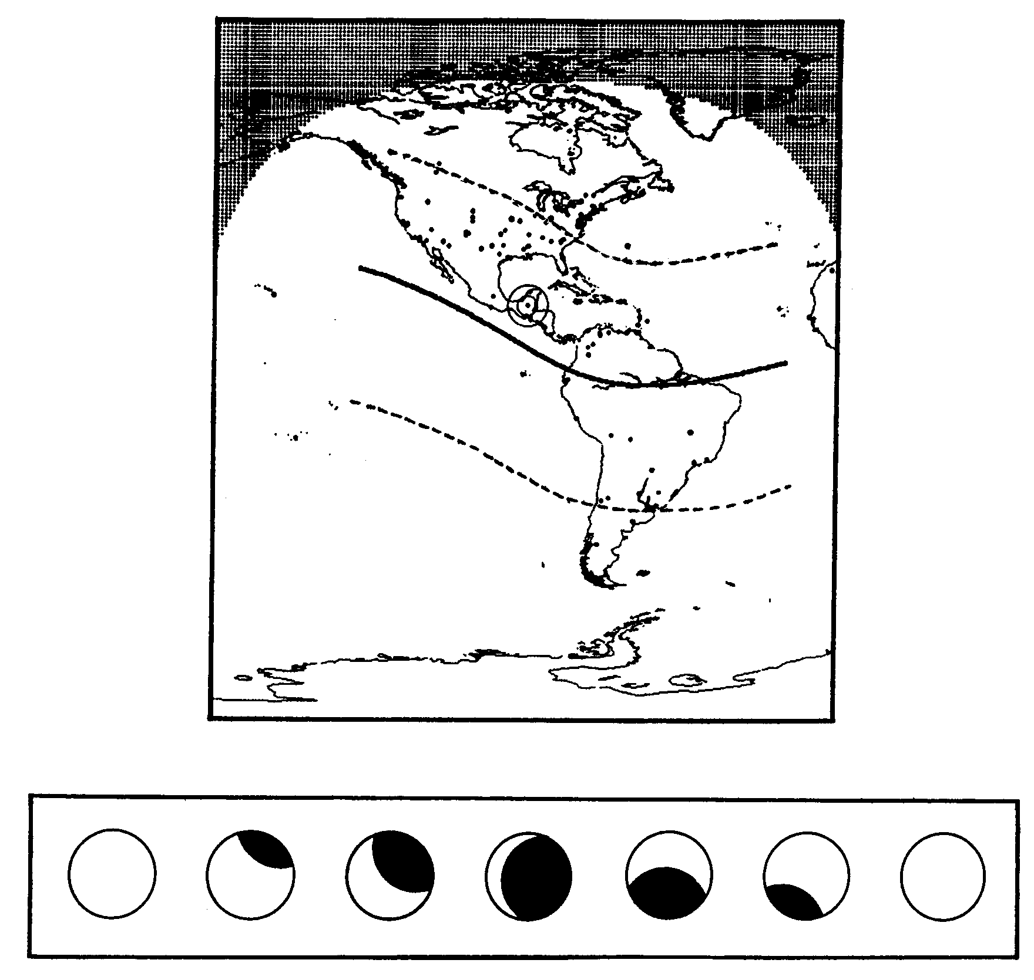

Figure 2
The progress of the solar eclipse on 29th October 859.
Codex Dresden, page D 31 (F 52).

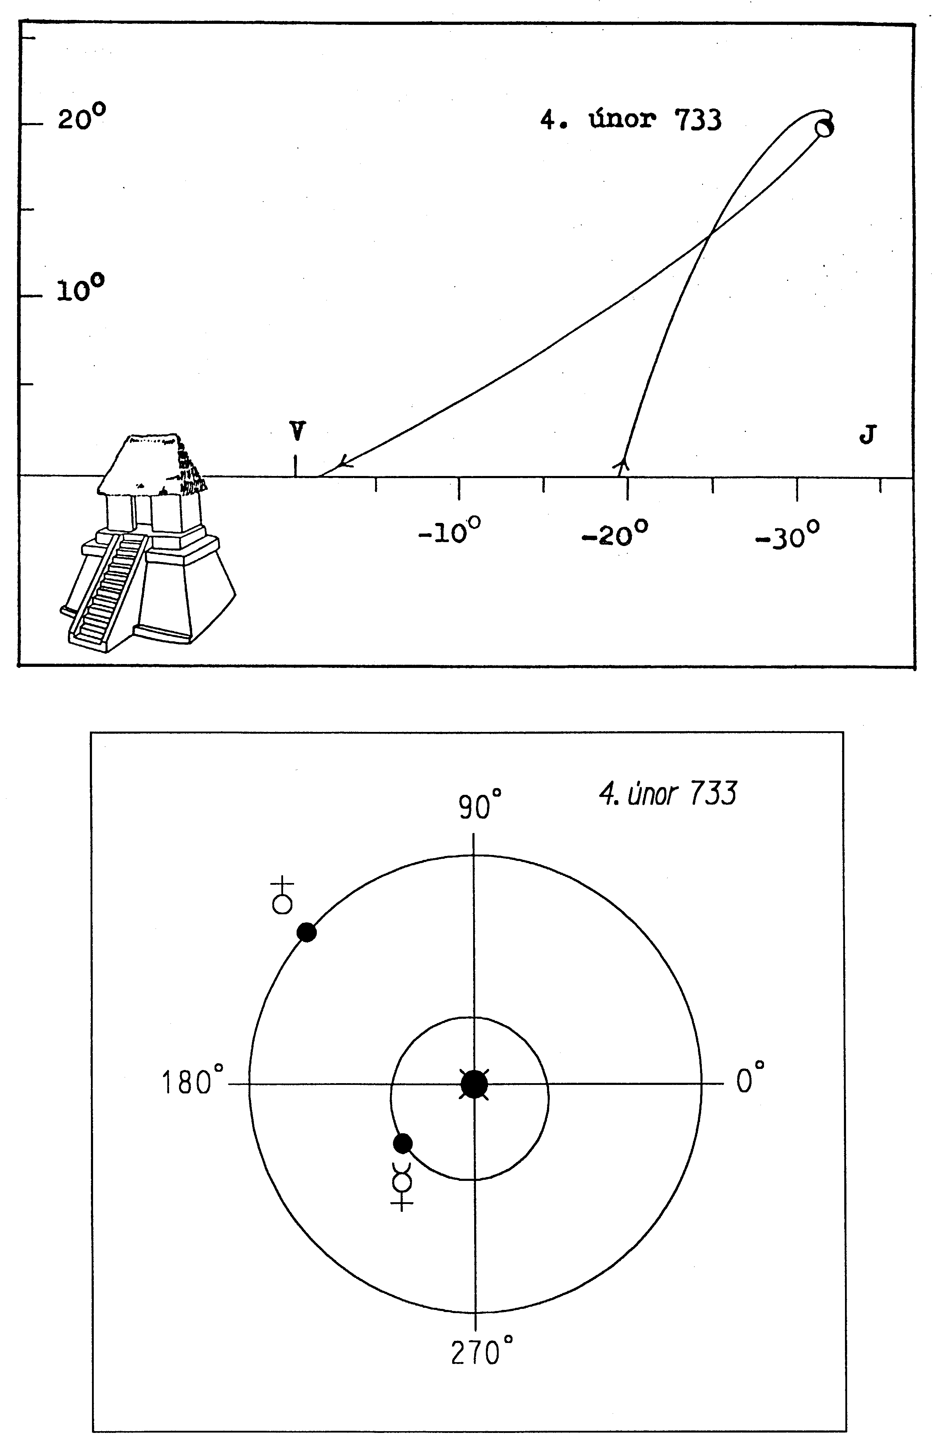

4 February 733
20⁰

10⁰

-
10⁰ - 20⁰ - 30⁰

- 10⁰
90⁰

270⁰

180⁰

E
S
0⁰

4th February 733
S
S

S
S

S

90⁰
270⁰

Figure 3
The position of Mercury in the morning sky shortly before sunrise from 7th
January 733 until 15th March 733. Close to its maximum western elongation
on 4th February 733. Date 9.9.16.0.0 4 Ahau 8 Cumku. Codex of Dresden,
page D 24 (F 24).

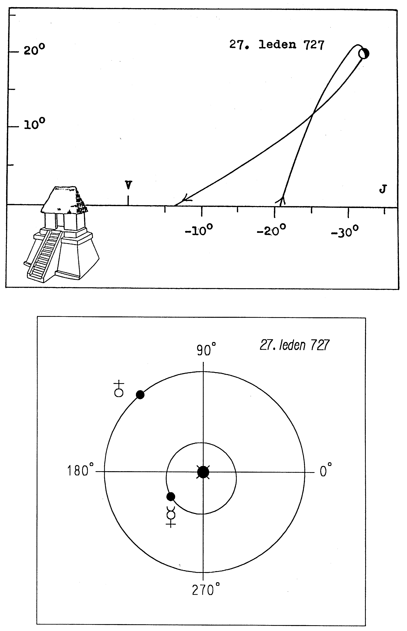

27th January 727
20⁰
10⁰
- 10⁰ - 20⁰ - 30⁰

E
-

90⁰
0⁰

180⁰

270⁰

J
S

Figure 4
18
The position of Mercury in the morning sky shortly before sunrise from 29th
December 726 until 5th March 727. Close to its maximum western elongation
on 27th January 727. Date 9.9.9.16.0 1 Ahau 18 Kayab. Codex of Dresden,
page D24 (F24).
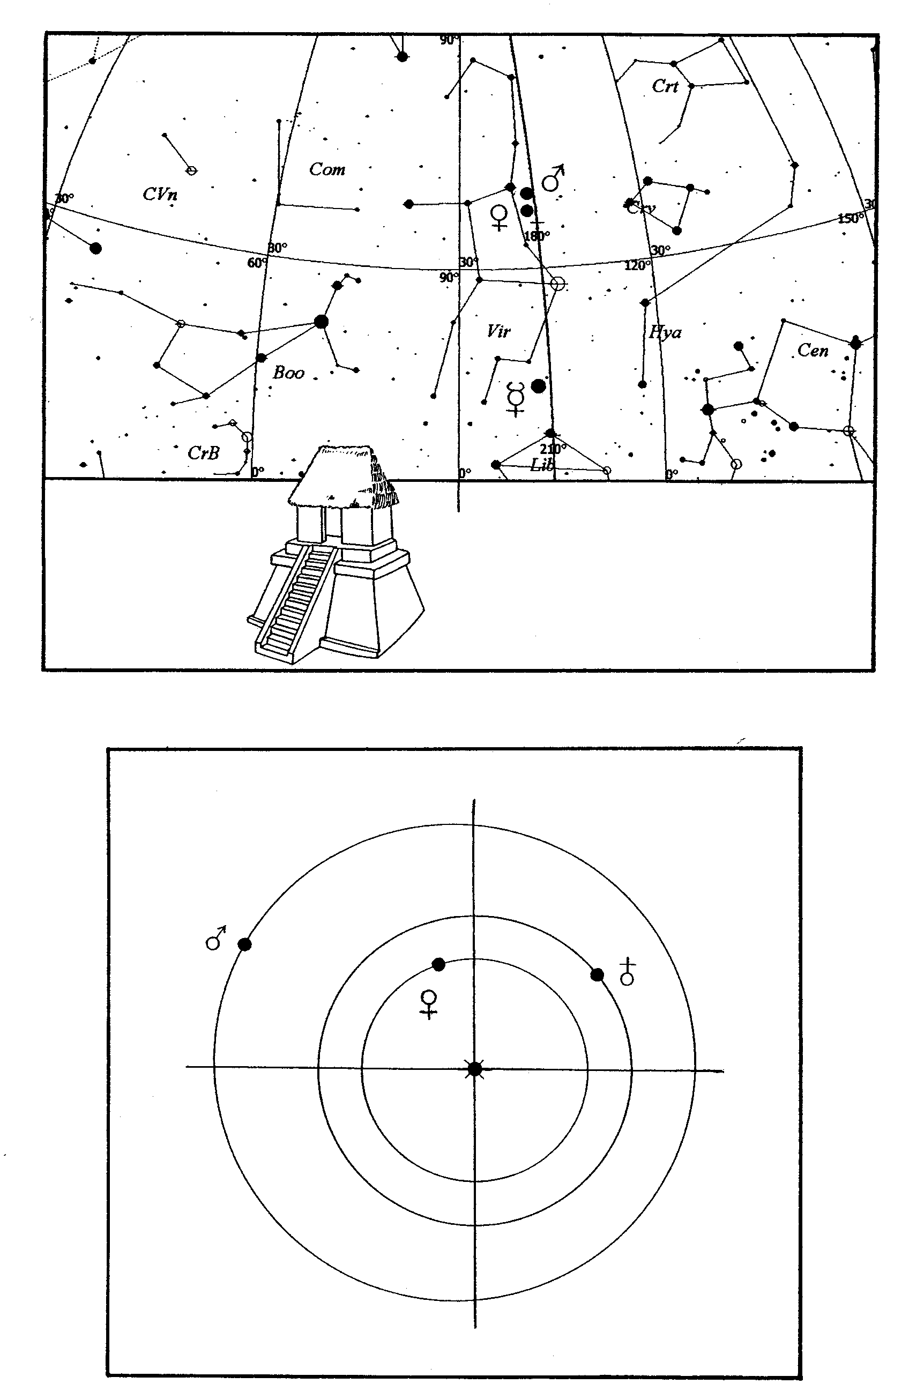

V J
V J
V S
V
E

0⁰

180⁰

90⁰
270⁰

Figure 5
The conjunction of Venus with Mars on 26th October 896. The position of
The planets as at 6.54 a.m. shortly before sunrise. Date 9.18.2.2.0 4 Ahau.
Codex of Dresden, page D37 (F58).

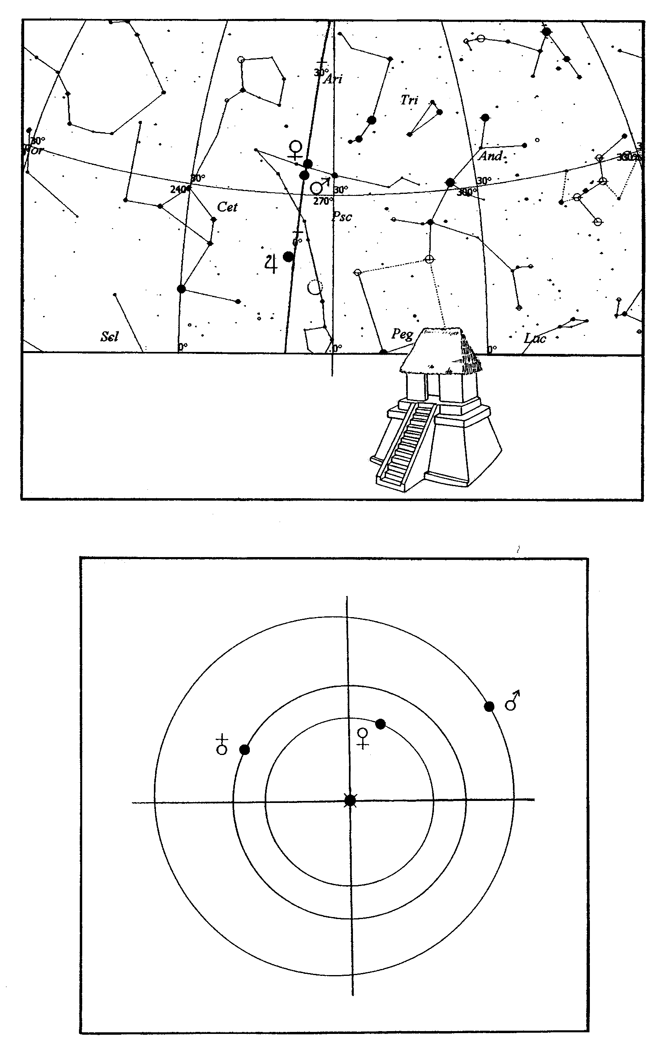

Z
J
J

0⁰

0⁰
90⁰

180⁰

J Z
J

S W
270⁰

W
S W
S

Figure 6
The conjunction of Venus with Mars on 18th February 896. The position of
the planets as at 7.13 p.m. shortly after sunset. Date (9.18.1.7.9) 13 Muluc.
Codex of Dresden, page D37 (F58).

180⁰

0⁰

90⁰

270⁰

V J
V J

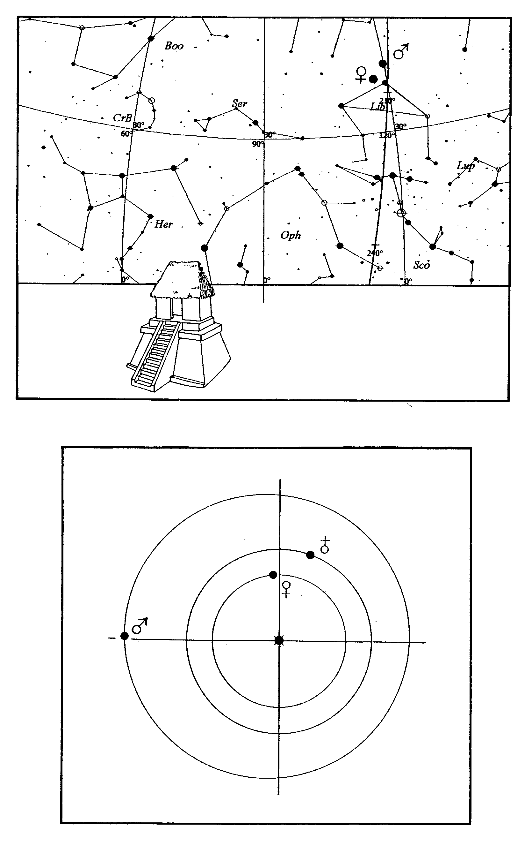
90⁰
0⁰

180⁰
270⁰
V J
V J
E S

180⁰

Figure 7
The conjunction of Venus with Mars on 28th November 787. The position of
the planets as at 7.10 a. m. shortly before sunrise. Date 9.12.11.11.0 4 Ahau.
Codex of Dresden, page D 37 (F 58).

