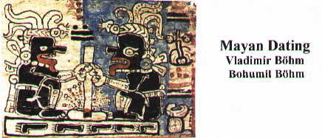

A calculation of leap years in the Codex of Madrid
Bohumil Böhm
Vladimír Böhm

The Mayan culture was based on highly developed agriculture, which succeeded to produce enough food for population strata pursuing non-farming activities either permanently or on the seasonal basis. Like other highly developed cultures of Asia, Africa and Europe, the Mayan farmers had to respect regularly alternating changes in the nature within the course of the year. In this way, a calendar was gradually designed, the complex system of which, as used by the Mayas, has no parallel worldwide.
The tropical year of 365.242 199 days is the basic time interval. Its two main nodal points include the summer solstice, when the Sun has the maximum north declination, and the winter solstice, with the maximum south declination (Enclosure 1). The length of the tropical year is not an integer number and thus as early as in the year 238 B.C. in Egypt, the leap year of 366 days was introduced following every three years of 365 days. Based on knowledge of Egyptian astronomy, the Alexandrian astronomer Sosigen reformed the Roman calendar in 46 B.C., likewise introducing the fourth year of 366 days as the leap year. It was named the Julian calendar, in honour of Julius Caesar. This calendar, following additional modification improving its accuracy by the professor of the University of Perugia Luigi Lilie, has been used since 1582 to date as the Gregorian calendar.
It is generally accepted in the scientific community that the Mayas failed to know the use of leap years of 366 days. Actually, these could not be placed anywhere in the system of the Mayan calendar from the classical period, since the system involved the concurrence of a number of cycles, namely:

the 260-day tzolkin coinciding after 18,980
the 365-day haab days the calendar circle coinciding after
170,820 days
the 9-day cycle after 6,832,800 days,
all cycles met
the catun cycle of 93,600 days subdivided
into 13 catuns of 7,200 days each, each
catun comprised twenty 360-day tuns

The concurrence of all calendar cycles formed an accurate harmonic system, holly for the Mayas. The insertion of a single day would result in its complete destruction. Combinations of days from the 260- and 365-day cycles coincided unrepeatably with a specific day of the 18,980-day cycle (the calendar cycle) and to it, a day of the nine-day cycle corresponded. Jointly, they were linked with a specific tun of the catun circle. The whole cycle closed up after 6,832,800 days, to start anew. Hence, the use of a leap year of 366 days was impossible. Consequently, every day had simultaneously a number of names. Moreover, a number was given standing for the number of days elapsing until the dated day from the beginning of the Mayan chronology (the long count). This complex system of dating using the long count plus the cycles mentioned above is found in inscriptions on the monumental heritage structures in cathedral cities. The system is not encountered at its full scope in Mayan codices. The Codex of Dresden includes long-count dates standing for the number of days elapsing from the beginning of the Mayan chronology until the dated day, which is denoted with its name from the 260-day tzolkin and the 365-day haab. Some dates identify the last day of the long count only with the date from the 260-day tzolkin, the date from the 365-day haab failing to be indicated. The nine-day cycle is not encountered. Excepting one example, more over one which is not completely clear, dating with the use of the catun circle is also not found.
In the Codex of Paris, the course of catuns in the catun circle plus the 260-day tzolkin are used for dating. Neither the long count nor the nine-day cycle are applied and hence the manuscript cannot be dated within the Mayan calendar. Analogously to the Codex of Dresden, cycles of 365-day year are expressed using dates from the 260-day tzolkin, but only within the framework of the calendar cycle of 18,980 days.
In the Codex of Madrid, dates are given exclusively in the system of the 260-day tzolkin. Only in one case, the date 13 Ahau 13 Cumku is presented. While the first date is from the 260-day tzolkin, the second is from the 365-day haab. The combination of the two dates falls on the 15,700th day of the calendar circle. Within the framework of the calendar circle of under 18,980 days, also the 365-day year is expressed in the Codex, namely through the 260- day tzolkin, as we will explain later. Neither the dates of the 9-day cycle nor the long count giving the number of all days from the beginning of the Mayan chronology are used.
The Codices of Paris and Madrid must have been compiled at a time when dating using the long count was not applied or was already forgotten. This is why these artefacts cannot be dated accurately within the Mayan dating system. No complexly harmonised calendar cycles as known from inscriptions in cathedral cities and partly from the Codex of Dresden, are found in the Codices of Paris and of Madrid. This is why apparently at the time around the compilation of the Codex of Madrid, the first successful attempt of definition of the leap year of 366 days was made, as its introduction in the calendar system resulted in no distortion to the harmony with other calendar cycles, which were apparently in disuse for a long time by then.
The origin of all surviving Mayan codices is logically assumed in Yucatan. From the Southern Mayan region, covering mainly the Guatemala highlands, but for very brief early hieroglyphic texts on monuments, no hieroglyphic inscriptions containing dates are known to exist in the boom period of development of the Mayan culture. It was only after the arrival of the Spanish that the first historical documents were drawn up, which start history with the invasion of marauding Toltec groups from Central Mexico. Roughly after the year 800, the central Mayan region was in steady decline until complete cultural collapse and abandonment of the magnificent cathedral cities in late 9th century, leaving the cities to jungle vegetation and abandonment. Cultural continuity, albeit under changed conditions, lived on in the northern Mayan region spreading mainly on the Yucatan peninsula. During the first third of the 10th century, armed Toltec groups penetrated into the region, referred to in later written chronicles at the Itzas or Tutul Xiu. During this so-called Mexican period lasting roughly until the year 1200, the newcomers totally dominated the Mayan society. Cultural decline showed not only in the absence of hieroglyphic inscriptions with dates but also in decline in architecture, the quality of which fell far short of that of the exquisitely built Mayan cities dating from the classical period. Since early 13th century, a big part of Yucatan became dominated by Mayapan. Its rulers, originally the descendants to the Mexican conquerors, adopted the Mayan language and gradually became integrated with the more numerous Mayan population. Mexican Gods are losing their prominence and, to a degree, there was a renaissance to the original Mayan Gods. The Mexican art forms, prominent in particular in architecture, which in Chichen Itza practically copied the Toltec buildings from the distant Tollan, weakened as well. Nevertheless, cultural decline continued. In mid 15th century, the rulers of other cities rebelled against Mayapan, which became totally ruined. The centralised state disintegrated in a number of smaller territories, the chiefs of which became involved in a series of devastating wars accompanied with total cultural ruin. The Codex of Madrid originated probably in the era of the Maya pan rule and is dated in the professional community in mid 15th century.

By the study and mathematical statistical analysis of hundreds of Mayan dates from inscriptions in the cathedral cities and also the Codex of Dresden, we obtained credible evidence that some of these relate to solstices or, rather exceptionally, equinoxes, which then became the starting days to determine the length of the tropical year. Over time within the framework of the 365-day haab, solstices naturally fell on different days, since the system of 366-day leap years was never introduce in order to avoid a disruption of the whole Mayan calendar system, the different cycles of which meshed one with another with gear-like accuracy. The system disruption started during the 10th century, when Yucatan was first invaded by alien marauding groups, probably the Toltecs, who forced their rule, culture Gods and also their calendar to the Mayas. Over a very short time, hieroglyphic inscriptions with Mayan dates, the systems of which the newcomers apparently have not even started to understand, ceased to be made. The only remaining dating was that within the 260-day cycle, which was known in a number of developed cultures of Mexico. In Yucatan, also the rough dating using the 7,200-day catun course survived until the arrival of the Spanish. Naturally, the 365-day year was also known, as all field works had to respect it.
While the run of the 365-day year can be expressed using the dates from the 260-day tzolkin, it can be done only within the framework of the 18,980-day calendar circle. This system has been deployed in the Codices of Dresden, Paris and Madrid. As an example, an entry from the Codex of Madrid in page M 35 can be used. The different dates within the 260-day tzolkin are separated with 160 days. Actually, to every preceding day 4 * 365 days, i.e. 1,460 days, must be added, falling on the next day from the 260-day tzolkin. The whole cycle closes after 18,980 days, for the calendar circle to start anew. The initial date of 11 Kan is the 124th day in the 260-day tzolkin:

11 Kan - 124th day 13 Kan - 204th day
4 x 365 = 1,460 days 4 x 365 = 1,460 days
2 Kan - 24th day 4 Kan - 104th day
4 x 365 = 1,460 days 4 x 365 = 1,460 days

6 Kan - 184th day 8 Kan - 4th day
4 x 365 = 1,460 days 4 x 365 = 1,460 days

10 Kan - 84th day 12 Kan - 164th day
4 x 365 = 1,460 days 4 x 365 = 1,460 days

1 Kan - 244th day 3 Kan - 64th day
4 x 365 = 1,460 days 4 x 365 = 1,460 days

5 Kan - 144th day 7 Kan - 224th day

4 x 365 = 1,460 days 4 x 365 = 1,460 days

9 Kan - 44th day 11 Kan - 124th day

4 x 365 = 1,460 days Total 18,980 days

Therefore, 18,980 days contain:
13 * 1,460 days, i.e. 52 * 365-day years without leap years or 73 * 260-day tzolkins.

As shown above, at the time of origin of the Codex of Madrid, the principle of the 18,980-day calendar, comprising the concurrence of the 260-day tzolkin and the 365-day haab, was still known. However, the system failed to address the problem of use of leap years. Their introduction into the Mayan calendar was possible only once the ancient harmonically meshing calendar systems dating from the classical period of the Mayan culture came to oblivion. That process started from late 10th century to continue in the centuries to come when the Guatemala highlands and the Yucatan peninsula were penetrated from central Mexico by Toltec marauding groups. The new peoples became to rule and religiously and culturally dominate the Mayan population in the region. The original Mayan calendar systems failed to be taken over but for the use of the 260-day cycle and the 7,200 catun course for very rough dating. The 260-day cycle had been probably known to the Toltecs before their invasion of the Mayan territory, since it had been used for dating in a number of urban and cathedral centres in central Mexico. It was apparently only during the Mayapan hegemony at the Yucatan peninsula (from early 13th to late 15th centuries) the introduction of the 366-day leap year in combination with the 260- day tzolkin took place. There was no more any danger of disrupting the different harmoniously meshing calendar cycles, which had been holy and untouchable for the Mayas in the classical period.
The evidence of use of leap years with the use of days of the 20-day cycle which was a part of the 260-day tzolkin, includes charts in pages M 13 to M 18 of the Codex of Madrid. These include four series of hieroglyphs of the twenty-day cycle (Enclosures 2 and 3). In the horizontal lines, the dates follow the arrangement of their actual succession, namely from the first Imix until the twentieth Ahau days. The general principle of the chart is that the dates must be read in vertical columns, as shown in their graphical presentation (Enclosure 3). After 3 * 5 days, there follows an interval of 6 days which is situated always between two vertical columns of the day hieroglyphs. Five and six days are replaced respectively by the 365 and 366-day intervals. Thereby, a typical four-year interval of three 365-day and one 366-day years is obtained, as it is nowadays used. Graphically, the system can be visualised as follows:

Imix Ik Akbal etc.

365 365 365
Cimi Manik Lama
365 365 366 365 366 365
Chen Eb Ben
365 365 365
Cib Caban Etznab

The whole cycle, which is incomplete in page M 18, contains 156 * 365-day years plus 51 366-day years, that is 75,606 days. These contain 207 tropical years of 365.242 199 days with the error of + 0.867 day.
With long-term observation of the sunrise and sunset points, two moments of the tropical years of the greatest significance for the farmers, i.e. the solstices, can be fairly accurately established. It is the summer solstice when the Sun has the greatest north declination at sunset and sunrise and the winter solstice with the greatest south declination. The spring and autumn equinoxes are but derived from the solstices. From the intervals between the solstices, the actual length of the tropical year can be calculated. Naturally, the accuracy depends on the number of solstices observed and the counting of days separating them. It was the summer solstices, which became the basis for charting the course of the tropical years with correctly placed leap years of 366 days, as presented in the Codex of Madrid. That is evidenced also by the related iconography, which complements the columns of characters of the twenty-day cycle, i.e. the depiction of pouring rain, even from a tipped vessel in page M 14. A similar motif can be found also in the Codex of Dresden. The scene is completed with the images of four Chacs, the four Gods of Rain, with their attributes of golden axe, held in their hand. They belonged among the most venerated and prominent Mayan Gods. The year at the Yucatan is split into two basic seasons: the dry winter and the rainy summer ones. The driest months in the year include December, January, February, March and April, with the average monthly precipitation ranging from 17.8 to 27.9 mm. The rainy months include June, July, August and September, with monthly precipitation between 134.6 and 177.8 mm in June, when the precipitation is the heaviest and the summer solstice occurs. The tropical year chart can be also understood as a method to determine the arrival of the wettest period, coinciding with the summer solstice.

The Codex of Madrid fails to include the system of dating using the so-called long count as known from the inscriptions in cathedral cities or the Codex of Dresden, since it was no more known at the time when the Codex was written and there was no one anymore being capable of correctly proceed with the system of counting of days from the beginning of the Mayan chronology as used throughout the classical period of the Mayan culture. This prevents dating the artefact accurately within the Mayan dating system.Nevertheless, for the charts of the course of the tropical years. there are some possibilities how to date them. We know that they are based on the heaviest rainfall around the summer solstice. Pages M 13 and M 17 show hieroglyphs of the solar eclipse. These hieroglyphs are also in page M 12, shown alongside images of pouring rain. It is hence justified to assume that a solar eclipse big enough to merit to be recorded and linked with this important calendar period occurred close to some summer solstice. The following chart shows all such eclipses occurring between the years 900 and 1536 and visible from the Yucatan region. The chart includes the following information:

The date when the solar eclipse occurred.
The corresponding Julian days.
The eclipse maximum in per cent.
The local time of the eclipse maximum.
The date of the summer solstice.
The difference in days between the solstice and the eclipse.

Date Julian days Maximum in % Local time Solstice Difference

18. VI. 931 2 061 274 61 % 9:53:44 17. VI. 931 + 1
18. VI. 996 2 085 016 72 % 13:05:00 16. VI. 996 + 2
9. VI. 1043 2 102 173 63 % 18:17:49 16. VI. 1043 - 7
11. VI. 1192 2 156 598 44 % 8:55:28 14. VI. 1192 - 3
13. VI. 1238 2 173 401 32 % 13:06:36 14. VI. 1238 - 1
13. VI. 1257 2 180 341 25 % 14:19:14 14. VI. 1257 - 1
25. VI. 1340 2 210 669 61 % 13:45:56 13. VI. 1340 + 12
26. VI. 1405 2 234 411 86 % 11:19:07 13. VI. 1405 + 13
28. VI. 1451 2 251 214 34 % 17:45:47 13. VI. 1451 + 15
17. VI. 1452 2 251 569 98 % 7:57:21 13. VI. 1452 + 4
28. VI. 1470 2 258 154 11 % 18:13:50 13. VI. 1470 + 15

Some eclipses from those indicated in the above chart can be excluded. These are those in years 931 and 996, since these are too early ones. In recording these dates, the author would have probably used the long-count system giving the number of all days passing since day one of the Mayan chronology until the eclipse date, as is the case in the Codex of Dresden. While the Toltecs have already started to penetrate on Yucatan, the old dating system from the classical period has not yet been fully forgotten. It is evidenced by stele 2 from Quen Santo and stele 10 from Xultun. The eclipses in years 1340, 1405, 1451 and 1470 are quite far away from the summer solstice. The Mayas most likely would not have made an error of 12 to 15 days in determining it. The most likely one is the solstice of 17th June 1452 with the maximum of 98%. It progress in time was as follows (Enclosure 4):

the beginning of the eclipse 6:51:44
the maximum of the eclipse 7:57:21
the end of the eclipse 9:13:08

The eclipse took place four days after the summer solstice. Over the time, the Sun moved southwards from its maximum north declination by 0.080 degrees. It is an angle beyond measurement by the tools of the period. According to Böhm’s correlation of 622,261 days, the eclipse day falls on the Lamat day of the twenty-day cycle. The findings obtained by analysis of pages M 12 – M 18 of the Codex of Madrid can be summarised as follows:

- The intervals between the different days of the twenty-day cycle in vertical positions contain a system of leap years counting in the (3 * 365 days) plus 366 days format.
- The initial dates are formed by the summer solstices when the heaviest rainfall culminates at Yucatan. Symbols of pouring rain are shown in the different pages together with images of the Rain Gods, the Chaks.
- Near the date of one summer solstice a solar eclipse occurred, the hieroglyphs of which are found in pages M 13 and M 17. In page M 12, which seems to be the introductory page those to follow, the God Chak is shown with two solar eclipse symbols from which streams of rain are running.
- The solar eclipse of 17th June 1452 was the biggest in scope over the studied period between years 900 and 1536, and one meriting record. While those of 26th June 884 and 29th May 1025 with equal maximum of 98% were as big, these two were fairly remote from the summer solstices.
- 17th June 1452 relates to the century in which the origin of the Codex of Madrid is generally dated. On which of the Lamat days the eclipse falls cannot be told as the summer solstices chart spans 207 years and the Lamat day appears ten times in it.

In some pages of the Codex of Dresden, solar eclipse hieroglyphs with streams of rain and the God Chak are also drawn. The meaning of the iconography and the accompanying dates will be studied by the authors of the present paper.
The collections of the Naprstek Museum which is a part of the National Museum include the so-called Codex of Prague. It is another Mayan manuscript held to be a counterfeit since 1956. It shows hieroglyphic series of the twenty-day cycle similar to those found in the Codex of Madrid. These are also arranged in the 3 * 365 + 366 day system. Also in this case, the idea is to design charts for the establishment of the accurate length of the tropical year over a certain period. An analysis of these charts was made in a study to be published in 2003 in Annals, the professional community bulletin published by the Prague Naprstek Museum.

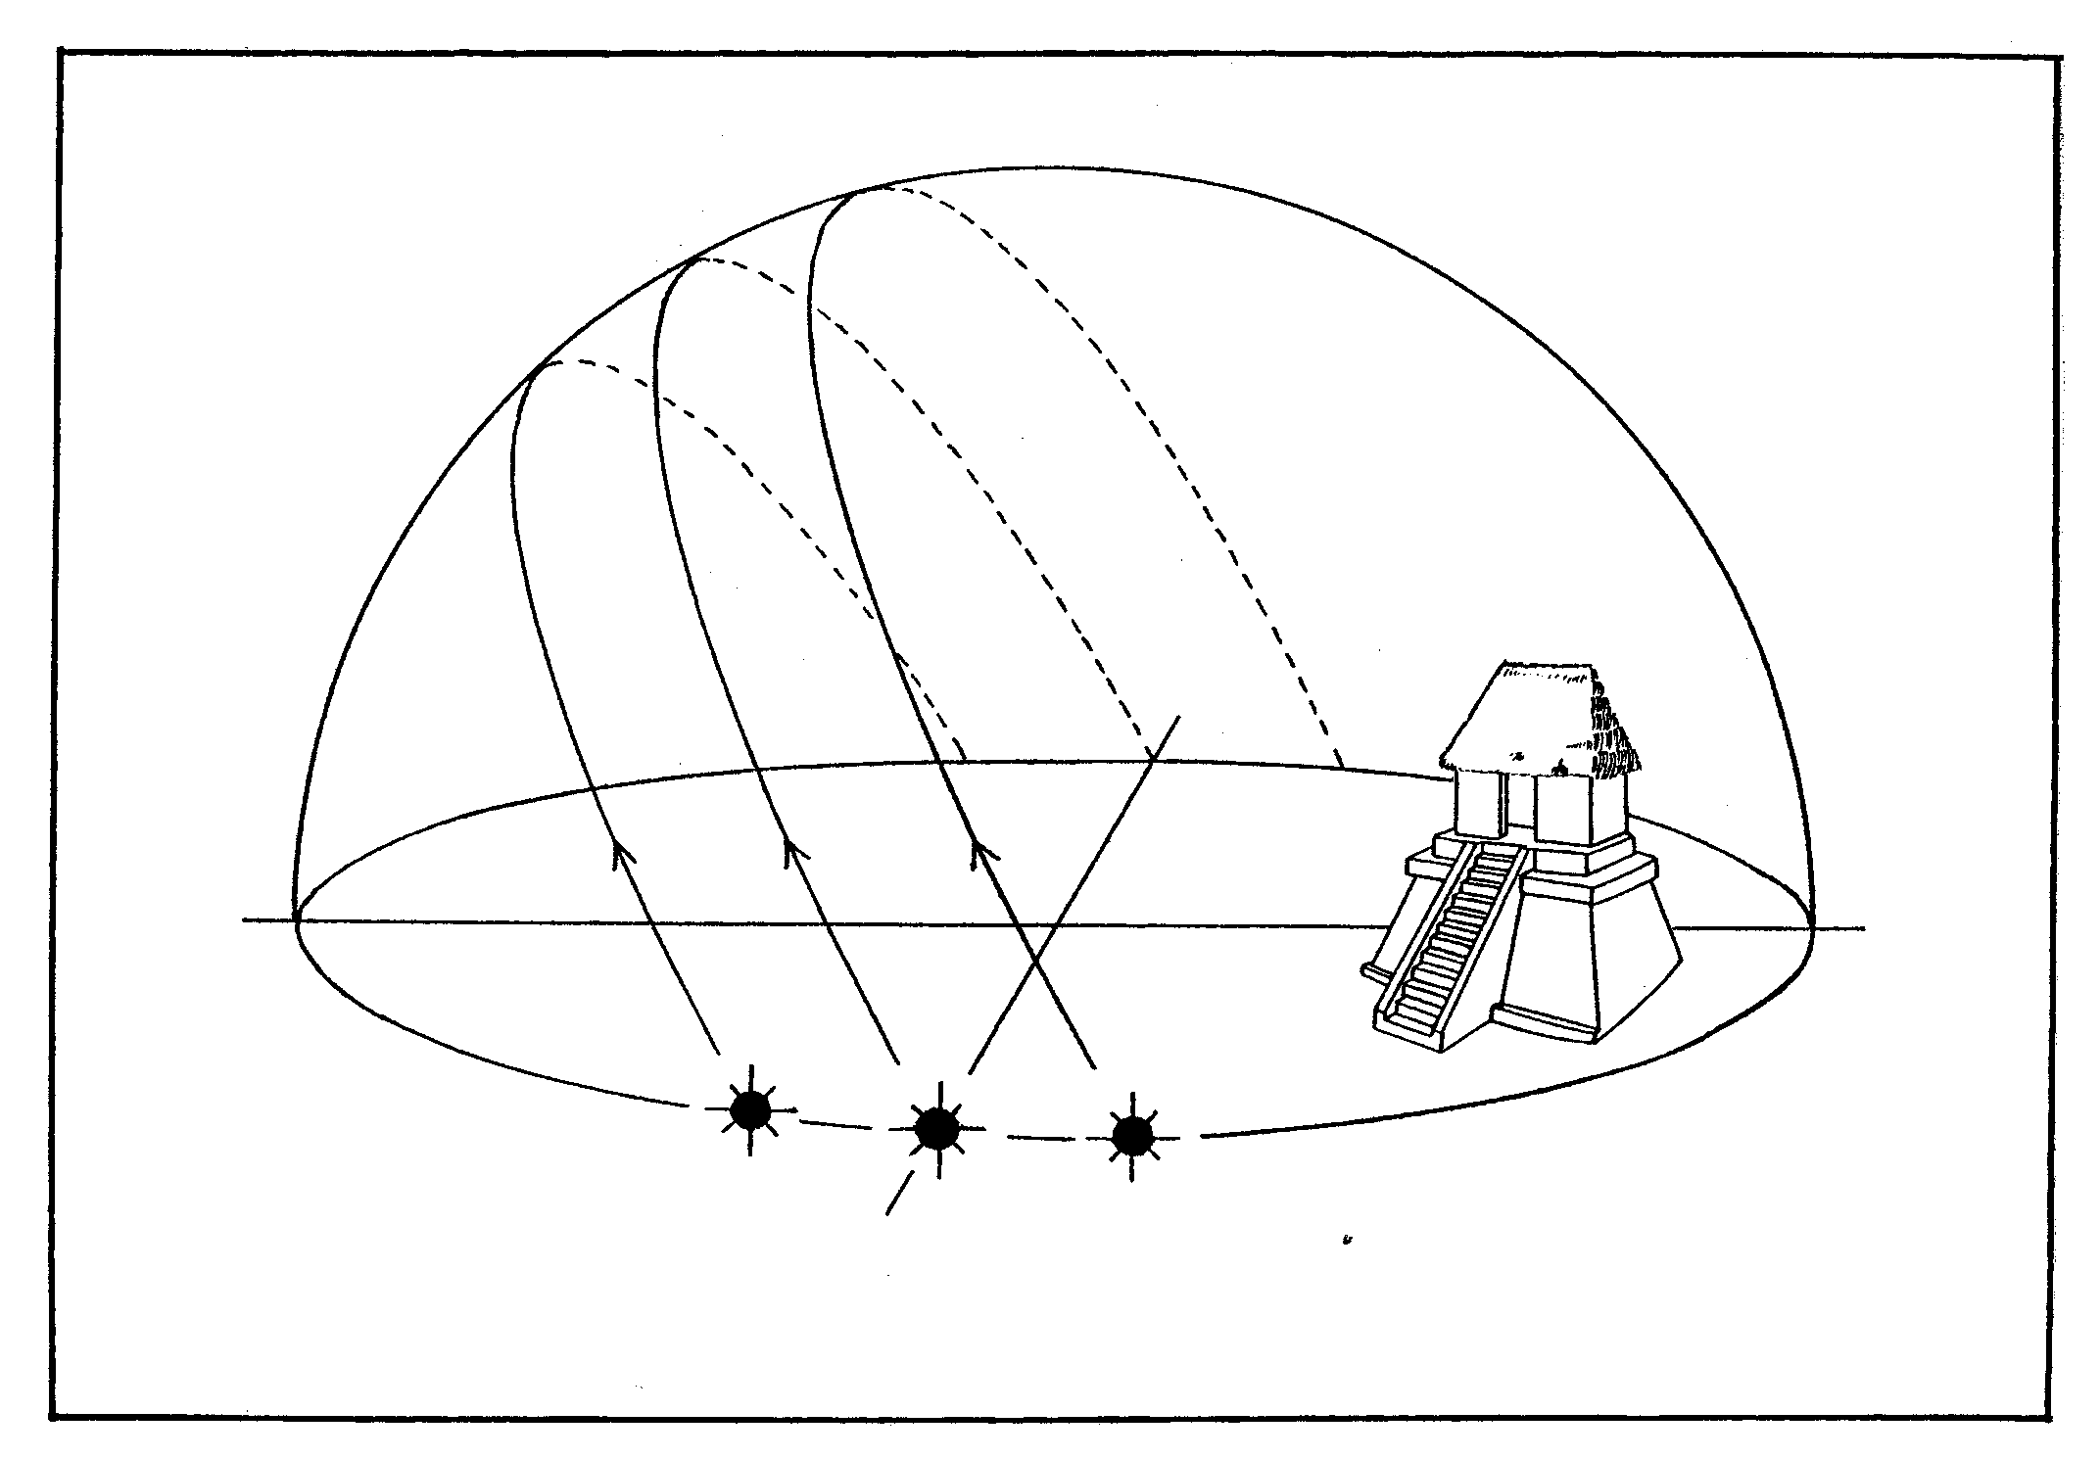

S

N

WWWZ
A C
E
B C
A

Anexo 1

Enclosure 1

A schematic diagram of the seeming movements of the Sun in the nodal points of the tropical year.

- The winter solstice. The Sun rises and sets with the greatest south declination of –23.5 degrees from the equator.
- The spring and autumn equinoxes. The Sun passes over the Earth equator and has the declination of 0 degrees.
- The summer solstice. The Sun rises and sets with the greatest north declination of +23.5 degrees from the equator.

Esquemae

Enclosure 2
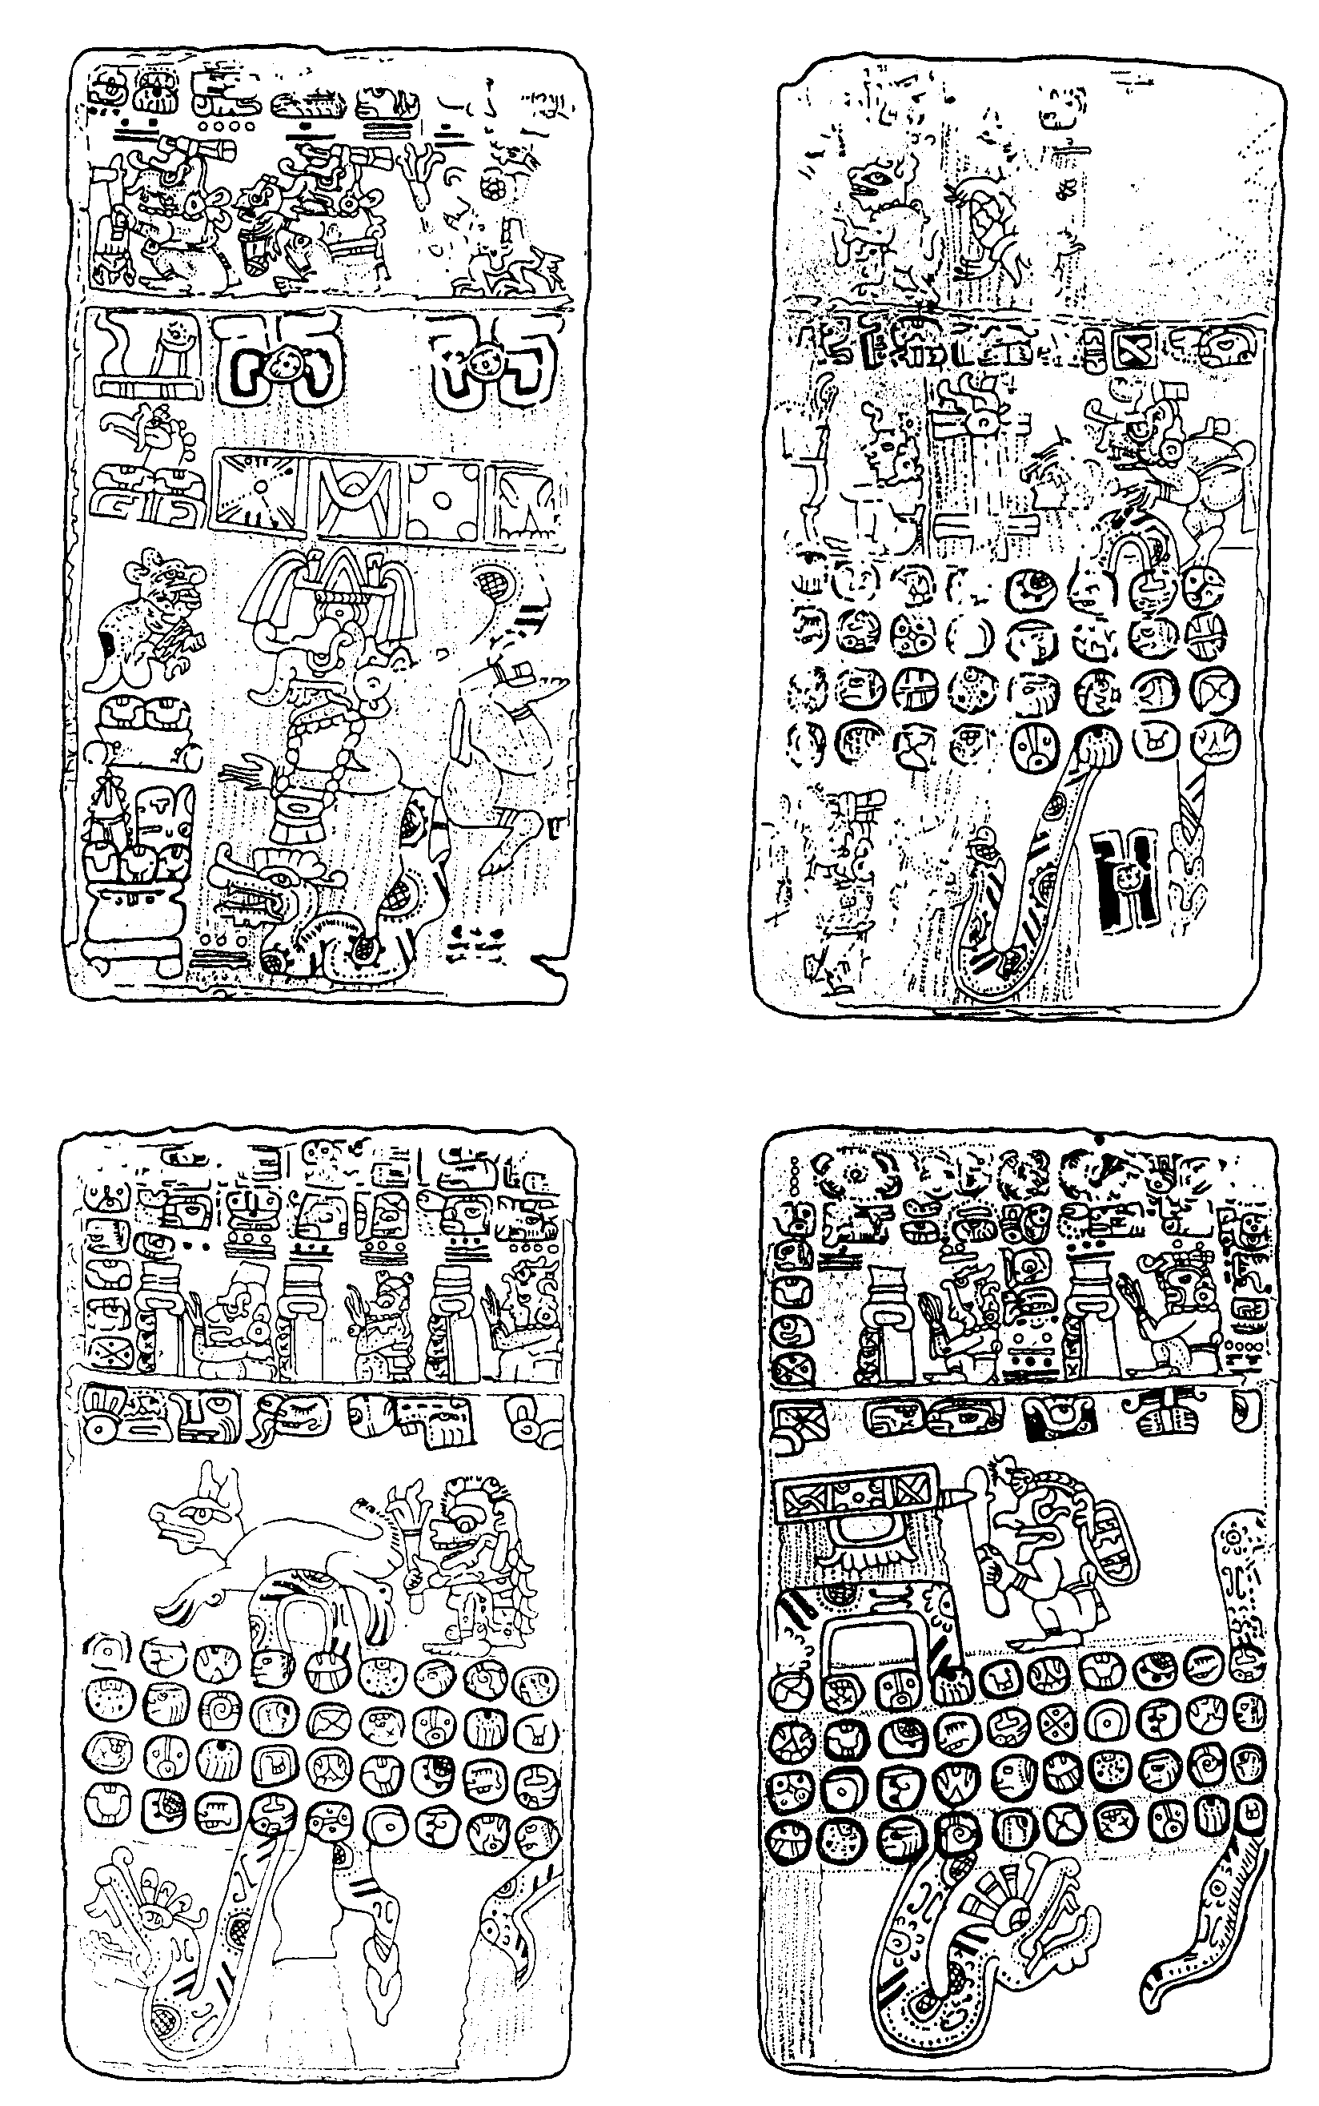

The Codex of Madrid. Pages M 12, M 13, M 14, M 15.

Enclosure 2 (continuation)
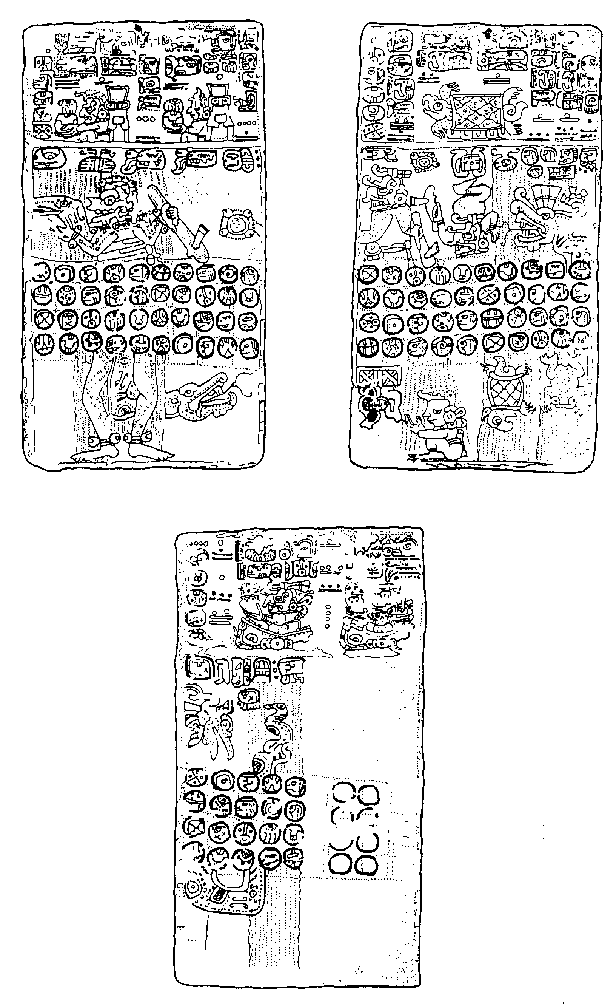

The Codex of Madrid. Pages M 16, M 17, M 18.

Enclosure 3

Imix Ik Akbal Kan Chicchan Cimi Manik Lamat
5 5 5 5 5 5 5 5

Cimi Manik Lamat Muluc Oc Chuen Eb Ben
5 6 5 6 5 6 5 6 5 6 5 6 5 6 5
Chuen Eb Ben Ix Men Cib Caban Etznab
5 5 5 5 5 5 5 5
Cib Caban Etznab Cauac Ahau Imix Ik Akbal

6

Muluc Oc Chuen Eb Ben Ix Men Cib
5 5 5 5 5 5 5 5
Ix Men Cib Caban Etznab Cauac Ahau Imix
5 6 5 6 5 6 5 6 5 6 5 6 5 6 5

Cauac Ahau Imix Ik Akbal Kan Chicchan Cimi
5 5 5 5 5 5 5 5
Kan Chicchan Cimi Manik Lamat Muluc Oc Chuen

6

Caban Etznab Cauac Ahau Imix Ik Akbal Kan
5 5 5 5 5 5 5 5
Ik Akbal Kan Chicchan Cimi Manik Lamat Muluc
5 6 5 6 5 6 5 6 5 6 5 6 5 6 5

Manik Lamat Muluc Oc Chuen Eb Ben Ix
5 5 5 5 5 5 5 5
Eb Ben Ix Men Cib Caban Etznab Cauac

6

Chicchan Cimi Manik Lamat Muluc Oc Chuen Eb
5 5 5 5 5 5 5 5
Oc Chuen Eb Ben Ix Men Cib Caban
5 6 5 6 5 6 5 6 5 6 5 6 5 6 5

Men Cib Caban Etznab Cauac Ahau Imix Ik
5 5 5 5 5 5 5 5
Ahau Imix Ik Akbal Kan Chicchan Cimi Manik

6

Ben Ix Men Cib Caban Etznab Cauac Ahau

5 5 5 5 5 5 5 5
Etznab Cauac Ahau Imix Ik Akbal Kan Chicchan
5 6 5 6 5 6 5 6 5 6 5 6 5 6 5
Akbal Kan Chicchan Cimi Manik Lamat Muluc Oc
5 5 5 5 5 5 5 5
Lamat Muluc Oc Chuen Eb Ben Ix Men

6

Continuation

Enclosure 3 (Continuation)

Imix Ik Akbal Kan Chicchan Cimi Manik Lamat

5 5 5 5 5 5 5 5
Cimi Manik Lamat Muluc Oc Chuen Eb Ben
5 6 5 6 5 6 5 6 5 6 5 6 5 6 5
Chuen Eb Ben Ix Men Cib Caban Etznab
5 5 5 5 5 5 5 5
Cib Caban Etznab Cauac Ahau Imix Ik Akbal

6

Muluc Oc Chuen Eb

5 5 5 5
Ix Men Cib Caban
5 6 5 6 5 6 5
Cauac Ahau Imix Ik
5 5 5 5
Kan Chicchan Cimi Manik

Enclosure 4

The course of the solar eclipse on 17th June 1452.

