The Prague Codex – the fifth preserved Mayan manuscript
Bohumil Bohm, Vladimir Bohm

With its character and overall make the Prague Codex ranks to the four Mayan codices known under the names the Dresden Codex, the Parisian Codex, the Madrid Codex and the Grolier Codex. It is deposited in the Naprstek Museum in Prague that is a part of the National Museum of the Czech Republic.
The first analysis of this monument was performed by Cestmir Loukotka in 1956 and declared it a falsification of the 80's to the 90's of the 19th century. He thought erroneously that all lines of hieroglyphs of the Mayan twenty-days cycle were arranged chaotically only without any system. However, he stated correctly that the sets of some figures in that Codex could not logically exist at all in the system of Mayan calculations. Numerous illustrations were considered by this author only figments of the falsifier's imagination that ensued, obviously, from the knowledge of some of the original Mayan codices.
The Prague Codex is made of plant fibers covered by white stucco. It is 2834 mm long and is folded into the form of a folding picture-book forming 18 pages of the average dimensions 155 x 265 mm. The drawings are on both sides of the belt, so that the codex is formed by 36 pages. The structure and construction of the bearing part of the codex, i.e. the fibrous material, surface layer finish, dimensions of the pages and the degree of wear are practically identical with the make of the other known Mayan codices.
We performed a thorough analysis of the data of this codex, including a partial photographic analysis in the ultraviolet spectrum. The obtained results confirmed that, in its essence, it is an original Mayan manuscript which, at the end of the 19th century, was, however, covered by drawings from the major part and thus damaged considerably. Only in positive dark-overexposed snaps of the individual pages recognizable are the original figures and calendar data in the system of Mayan calculations and traces of original drawings. An essential part of this original surface was removed and replaced by new coloured illustrations, completely fabricated in some cases, in others ensuing from the motives of the Dresden and Madrid codices. Also the columns of the figures accompanying the pictures are completely chaotic and serve for filling in the vacant areas only.
Fortunately, on some pages the falsifier left the original structures, i.e. columns and lines of hieroglyphs from the twenty-days cycle that were not removed and covered by drawings. If we mark the individual drawn hieroglyphs of the twenty-days cycle by figures from one to twenty according to the positions that they are in the twenty-days cycle, then their sequence, algorithm and structure are so exceptional in many lines that that part could not have been drawn by the creator of the other overpaintings in the form of at random selected symbols. He even did not understand the simple procedure of creation of figures within the Mayan system of calculations. Here, we will present only a small section of pages 1 and 4. Shown in brackets are the Mayan names of the days:

9. (Muluc) 15. (Men)
interval 5 days interval 5 days
14. (Ix) 20. (Ahau)
interval 5 days interval 5 days
19. (Cauac) interval 5 days 5. (Chicchan)
interval 5 days interval 5 days
4. (Kan) l0. (Oc)
interval 6 days interval 6 days
10. (Oc) 16. (Cib)

Among the individual days there are the following differences, namely 5, 5, 5, 6, 5, 5, 5, 5, 6 days. Such a correspondence could not occur, of course, in random drawing of symbols of the twenty-days cycle. Here, evidently, it is the original recording of the course of tropical years and, in particular, days to which some of the nodal points of the year fall that are the equinoxes or solstices. If we add 365 days to the Muluc day which is the ninth day of the twenty-days cycle and the first day of the left column of the above-mentioned scheme, then the sum falls on the 14th day which is the Ix day, as marked in the presented specification. The five- and six-days intervals may therefore be replaced with cycles of 365 and 366 days:

9. (Muluc) 15. (Men)
interval 365 days interval 365 days
14. (Ix) 20. (Ahau)
interval 365 days interval 365 days
l9. (Cauac) interval 365 days 5. (Chicchan)
interval 365 days interval 365 days
4. (Kan) 10. (Oc)
interval 366 days interval 366 days
10. (Oc) 16. (Cib)

The sum of all differences among the individual days of the twenty-days cycle may be expressed by the mathematical equation (7 x 365 days) + (2 x 366 days) = 3287 days. This set includes exactly nine tropical years (365.242199 days) with the error only + 0.18 days. The accompanying numerical intervals of the values 365 and 366 days that are, in fact, included among the days of the twenty-days cycle but, unfortunately, they were removed as not interesting and replaced with naïve illustrations with seemingly Mayan subjects. Also in the calendar data of the Dresden Codex there is a lot of data from the twenty-days cycle that, in parallel with the thirteen-days cycle, form the sacred 260-days cycle. Although between two days within the framework of the twenty-days cycle there is the interval of several days only, in fact it has the value of the order of ten, hundred, even thousand days that are marked in that codex in the form of accompanying numerical lines.
On page 4 of the Prague Codex, similar as on other consequential pages, there is the configuration of columns of days by threes that are linked up analogically as on the first page. The names of days of the twenty-days cycle are, for clearness sake, replaced again by figures in the sequence in which they are located in that Mayan cycle. The intervals between the individual days in vertical columns are again formed by 5 or 6 days:

18. 13. 9. 5. 1. 16. 12.
5 days 6 days 5 days 5 days 5 days 6 days 5 days
3. 5 days 19. 5 days 14. 5 days 10. 6 days 6. 5 days 2. 5 days 17.
5 days 5 days 6 days 5 days 5 days 5 days 6 days
8. 4. 20. 15. 11. 7. 3.
8. 4. 20. 15. 11. 7. 3.

When using the same algorithm that we saw on the fist page of the codex already, we get five identical groups with regularly repeated time intervals among the days of the twenty-days cycle, namely, 5 days, 5 days, 5 days, 6 days. The intervals of five and six days may be replaced again with cycles of 365 and 366 days. We create the sequence 5 x (3 x 365 days + 1 x 366 days) which represents 7305 days, i.e. 20 tropical years with the error of 0.16 day. In this case it is the calculation of the exact length of the tropical year as it is used also at present. After three years of 365 days each one leap year of 366 days is inserted.
The significance of arranging the symbols of the days of the twenty-days cycle on the pages of the Prague Codex does not apply only to the observance of the course of the tropical year. The algorithm of the symbols is so well-considered that, on several pages in horizontal lines of seven symbols of days on each between each neighbouring two days the length is included of four synodic periods of the planet Venus rounds. During check modelling of random numerical structures of identical configurations as those on the pages of the Prague codex and finding out what the probability is of a random occurrence of the above-mentioned phenomena such a small probability ensues that it practically cannot be even defined – less than 10⁻⁹. Interesting synchronous lines of the days of the twenty-days Mayan cycle are also on other pages of that Codex and it is evident that they also have their realistic basis. They are the subject of further intense studies of ours and their analysis would far exceed the extent of this basic information. At the stage of preparations is the photographic scanning of the Codex in different spectra of invisible radiation, using the latest displaying technique that could shield the later overpaints and reveal further original calendar recordings and the content of the pages that are not obvious at first sight. This method was used very successfully in the past already to reveal falsifications of some of the Czech manuscripts that fell, with their content, to the 12th and 13th centuries.
After processing all preserved original Mayan data and making the content of the original pages visible within the framework of the possibilities of the present-day technical equipment, the Prague Codex will be published completely and made accessible for the widest public.

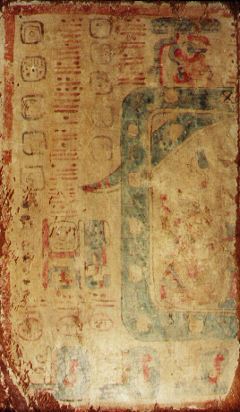

Page 1
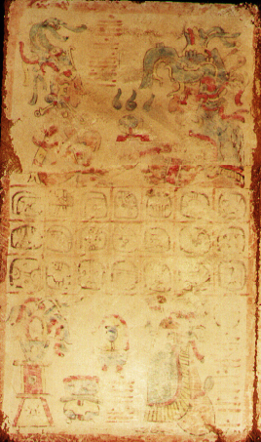

Page 4

